**Trinity United Church of Christ**



***October 2023***



***Worship: 9:00 am ONLY Service starting October 1st***

**------------------------------------------------------------------------------------------------------------------**

**October 1 –** 1 Corinthians 12

“We Are the Body!”

**October 8 –** Matthew 21:33-46

Sad News / Good News

**October 15** – Matthew 22:1-14

What Are We Wearing?

**October 22** – Matthew 22:15-22

Render to Ceasar

**October 29 –** Matthew 22:34-46

Loving Who, What & How

**Communion: Please pick up your communion wafer & cup as you enter the sanctuary.**

**Offering: Please place your gifts in the offering box as you enter or leave worship.**

**Contact Information**

**Pastor: Rev. Karen Fraser Moore**

welwoman@hotmail.com, 618.920.3592

**321 W. 8th Street … Jasper, Indiana 47546**

(Corner of Clay & 8th Street)

**Mailing Address:** PO Box 386

Jasper, Indiana 47547-0386

**Office Administrator**: Taylor Popp

**Office Phone:** 812-482-4090

**Office Hours:** Monday, Wednesday & Thursday

9am – 1pm & 2pm - 3pm

**Website:** htps://www.trinityjasperucc.org



**Monthly Calendar**

**SU 1** 9:00 am Worship & Communion

**M 2** 9:00 am Music Together

**W 4** 3:00 PM KICS - JMS

7:00 pm AA Meeting

**F 6** 10:15am Mommy & Me Playgroup

7:00 pm AA Meeting

**SU 8** 9:00 am Worship

10:00 am Men’s Fellowship (lounge)

Women’s Guild (kitchen)

**M 9** 9:00 am Music Together

5:45 pmCE Team Meeting

7:00 pm Council Meeting

**T 10** 12:00 pmLincolnland Luncheon @ the Schnitzelbank

**W 11** 6:30 pm Worship Team Meeting

7:00 pm AA Meeting

**F 13** 10:15am Mommy & Me Playgroup

7:00 pm AA Meeting

**SU 15** 9:00 am Worship

**M 16** 9:00 am Music Together

**T 17** 6:30 pm Outreach Team Meeting

7:00 pm AA Meeting

**F 20** 10:15am Mommy & Me Playgroup

7:00 pm AA Meeting

**SU 22** 9:00 am Worship

4:00 pm Lincholnland Fall Meeting in Tell City

**M 23**9:00 am Music Together

**T 24 *Newsletter Articles Due***

**W 25** 7:00 pm AA Meeting

**TH 26 *Newsletter Sent***

**F 27** 7:00 pm AA Meeting

**SU 29** 9:00 am Worship

**M 30** 9:00 am Music Together

**Karen’s Kares**

As we approach October 2023, it is exciting to look back over the past few months at all God has been doing and is currently doing in our midst.

**The Christian Education Team** has begun a new educational program for our elementary age children of Trinity UCC. This endeavor (meant to replace the traditional Sunday School) began on September 20 at Jasper Middle School. The program will be held on the first and third Wednesdays of each month from 3:00 to 4:00 pm under the supervision of Dana Blackman. Several people from the congregation have volunteered to assist Dana with various activities during that time. In addition, the congregation will be providing “snack” items for the children to enjoy when they arrive.

**The Bridge Team** will be completing its work soon so a Search Team can be selected. Everyone within the congregation has the opportunity to **suggest (nominate)** one or two persons they believe would represent Trinity well in the completion of the Congregational Profile and in the process of selecting the new pastor.

**The Church Council voted** at their September meeting that the congregation move from having two weekly worship services to **having only one weekly service of worship** which will now begin **at 9:00 am**. When worship is over (by 10:00 am) then Team meetings, classes, or other events can be held. In fact, on **October 1, 2023 (the first Sunday of our new schedule), the Council will provide a Breakfast Brunch immediately following worship that day.**

At a meeting of folks interested in helping our congregation become more hospitable, a **group of volunteers agreed to come together and study the UCC process of potentially becoming an Open and Affirming congregation**. This group has not yet met but will be meeting soon. If you would like to participate with this process, please let me know. We will refer to it as the **ONA Hospitality Team.**

**The Church Office** has installed a new software package (CDM+) which will allow us to create a new congregational database. Hopefully, before the end of 2024, we will be able to celebrate a new church directory and have the ability to create lists of various types to improve the efficiency of the work.

**The Technology Team** is close to making some final decisions about the equipment needed to be able to stream our services of worship. Again, hopefully by the end of 2024, the equipment will be purchased, installed and ready to record and place our worship services online.

God’s Holy Spirit is at work in our midst beginning to provide us with glimpses of all God has and is calling us to be and become. What prayers do we have as we prepare to enter a New Church year (beginning December 1) of celebrating **“GOD WITH US?”**

In Christ’s Love and Kare, *Pastor Karen Fraser Moore*



**WORSHIP SERVICE UPDATE!**

Starting on October 1st, 2023, Trinity UCC will only have one Worship Service at 9:00 am every Sunday morning.

An updated Worship Participants schedule is included in this newsletter!

**MOMMY AND ME PLAYGROUP**

Mommy and Me Playgroup has had so much fun during September. “Bugging Out” was the theme for their September 1st meeting. Twenty-Two children enjoyed a scavenger hunt, played and learned at bug stations, and made an earth pudding snack.

There were nineteen pirates, princes, princesses, and fairies on September 15th when they were part of “Fairy Tale Time”.

 Thank you to Elizabeth Dellinger for all of her time and creativity to provide these experiences for the families.



**Corrine Clark** *Legacy Living, 1850 IN-56, Rm. # 202 (812-482-3482)*

*Jasper, IN 47546*

**Sherry Malone** *660 Rumbach Ave. Apt. #322 (812-582-2721)*

*Jasper, IN 47546*

**Claire Rohleder** *Legacy Living, 1850 IN-56, Rm. # 137 (812-482-3185)*

*Jasper, IN 47546*

**Alene Frank** *Good Samaritan Society (Garden Ridge) (812-482-1722)*

*2515 Newton Street*

*Jasper, IN 47546*

**Shirlene Dreher** *St. Charles Health Campus, 3150 St. Charles Street (812-634-5670)*

*Jasper, IN 47546*

**Linda Troxler** *Legacy Living, 1850 IN-56, Rm. # 237 (812-556-3196) Jasper, IN 47546*

**Janice Sunderman** *Legacy Living,**1850 W State Road 56, Apartment 134* *(812-559-0560)*

*Jasper, IN 47546*



**Pray without ceasing…**

* Pray for ALL in need of healing; may God grant them strength and patience.
* Pray for those impacted by the devastations from wind, fire & water.
* Pray for those families and communities where the young and elderly have been killed by senseless violence in various places in our country, including children in schools, those getting groceries, and those attending worship.
* Pray for our military, first responders and those in law enforcement.

**Mission Alive at Trinity**



**Adopt a Family: Year-to-date** we have collected **$1,868.05**

We appreciate your continued change jar support of our new family. Please remember them in your prayers, as well. We feel confident Trinity’s generosity will make 2023 a wonderful year for them!

**Food Bank**

**For too many people, providing food is a challenge.  Please help those who need our help by donations of bars of soap during the month of October.** This was an item the manager of the food bank asked us to add to our list.

Grocery stores sometimes donate food items that are about to expire. The Tri-State Food Bank gives our food bank a price break on some items. **Unfortunately, bars of soap are not one of those items, yet it is something most of us use.** Thank you for caring for others!

Thank you for donating **45 rolls of paper towels** to the food bank this month.  Not only can paper towels be given to the people in need, but they can also be used at the food bank as daily supplies.

**October items:  Bar Soap**

**College Care Gift Cards: supporting our college students!** Our goal was $150. Thanks to you, we were able to collect **$170** for Emma, Maggie, and Ella. The gift cards will show some love and support from home!

**Neighbors in Need Offering 2023- Behold!**

“God saw everything God made and behold, it was very good” Genesis 1:31

Trinity will be collecting donations for the Neighbors in Need offering starting on **October 8th until October 29th.**

The Neighbors in Need offering supports the UCC’s ministries of justice and compassion throughout the United States. Two-thirds of the offering is used by the UCC’s Justice and Witness Ministries to fund a wide array of local and national justice initiatives, advocacy efforts, and direct service projects. Working with members of the UCC Justice and Peace Action Network, Justice and Witness continues its strong policy advocacy work on issues such as the federal budget, voting rights, immigration, health care, hate crimes, civil liberties, and environmental justice. This year’s focus is on *Environmental Justice*.

Neighbors in Need also supports our American Indian neighbors in the UCC. One-third of the offering supports the UCC’s Council for American Indian Ministries. Today there are 20 UCC congregations on reservations and one urban, multi-tribal UCC congregation in Minneapolis, Minnesota. These churches and their pastors are supported by CAIM. CAIM is also an invaluable resource for more than 1,000 individuals from dozens of other tribes and nations who are members of other UCC congregations in the U.S.

Please use the envelopes in the pews or mail your offering to the church office

(315 W 9th Street, Jasper).  **This year's goal is $400.** Your support is very much appreciated. Thank you!

**Mission Alive at Trinity**

**Date Worship Attendance**

**September 3**   10:15am 41 **Total 41**

**September 10** 8:00am 19 10:15am 49 **Total 66**

**September 17** 8:00am 9 10:15am 35 **Total 44**

**September 24** 8:00am 10 10:15am 42 **Total 42**



**September Council Highlights**

|  |  |  |
| --- | --- | --- |
| **September Council Decisions:** | | |
| **- Approval was given for:** | |
| * beginning October 1, 2023, we will have only one service at 9:00 a.m. * approved spending $150 from the maintenance budget to paint the former youth room in the basement * approved spending $2450 from the maintenance budget to replace the windows in classrooms 210 and 213 upstairs |

**The next Council Meeting will be held on October 9th at 7:00pm.**

**We can help!**

How can we help YOU? The Outreach Ministry has received a couple of gift donations and we are anxious to share with the congregation.

You lovingly and generously support all of our missions throughout the year, so we decided to “pay it forward”. If ever you need a little help (eyeglasses, medical aids not covered by insurance, car or appliance repairs, etc.) please let us know.

We’re confident most people in our church family can handle an unexpected expense once in a while—but occasionally we all get blindsided by too many costs at one time. LET US HELP!!

We’ve set aside funds specifically for the purpose of helping you, our friends. Don’t be shy. If you have a need, please call Jan (812-630-7518) OR Pastor Karen (618-920-3592). All conversations will be confidential!!

We are eager to help ~ Outreach Team

**IT’S TIME TO THINK ABOUT 2024!**

**In terms of our Functional Teams and their updated responsibilities/**

As the end of 2023 draws near, we need to expand and update our Functional Teams for 2024. There are openings for new Co-chairs and additional members to join the following teams:

**OUR CHRISTIAN EDUCATION TEAM** – Co-Team Chairs are needed as well as additional members for this team as we make plans for 2024. It is hoped we will be able to plan, schedule and provide Bible Studies for Adults, Topical Studies for Adults, and additional programming for children. It’s time to be creative and reach out to the community with opportunities to grow our membership and educational endeavors. It will be possible for new opportunities to happen at 10:15 each Sunday following our 9 am worship.

**OUR WORSHIP TEAM (AND NEW SUB-TEAM)** – Co-Chairs are needed and additional members are encouraged to join this team in 2024. We would love to increase the number of folks who serve on the Worship Team with two emphasis: **1) paying attention to what needs to happen to decorate the sanctuary for each season of the liturgical calendar;** and **2) persons interested in assisting the pastor in planning how to enhance the meaning of worship so it becomes a more spiritual experience.** This sub-team will meet with the Pastor on a regular basis to share ideas and plan special emphasis throughout the church year. This sub-team will delve into the use of art, music, drama and other expressions for those things which cannot necessarily be expressed using words.

**NEW ONA HOSPITALITY TEAM -** Recently a group of folks met together to discuss how our congregation can become more Open and Affirming toward those who do not have a safe place to worship. Although in the past, ONA usually referred to folks in the LGBTQIA+ community, the intention now is to be inclusive of folks of different races, languages, backgrounds, skin colors, as well as those with limited physical and/or mental conditions.

For instance, how can we make our sanctuary more accessible and comfortable for those who need a wheelchair or walker to move freely about? How can we learn more about the Spanish-speaking community to possibly offer an alternative service of worship? How many of us are willing to learn to speak Spanish? How do we welcome those who are new to the community and are searching for a Spiritual home?

So many questions to consider making sure we become as inclusive as possible in all that we say, do and believe. This group is still open to any who are interested in learning more about **Radical Hospitality** and welcoming those who are different in a variety of ways. We want to deliver the message All People, regardless of who they are, or where they are on their journey, are loved by God as they are, and they are always welcome to worship or become involved in Trinity UCC

Questions? Contact Pastor Karen.

**SEARCH TEAM NOMINATION FORM**

The Church Council would like to provide everyone who attends Trinity the opportunity to “nominate” from among yourselves, people you believe would serve the congregation well in the process to completing the Congregational Profile and selecting the next pastor of the congregation.

Ideally, the congregation will be represented well by 5 to 7 persons in various age groups and in the length of time they have been attending Trinity UCC. You may nominate yourself. The Church Council will choose the Search Team from names presented on these forms.

**Please use this form to suggest one or two persons you would like to see represent the congregation on the Search Team Process:**

Names:

Please suggest one or two persons from the congregation.

Reasons you believe this person(s) will represent the congregation well in the Search Team Process:



**Time and Talent Sheet Information**

In order for our congregation to be aware of all the areas in which individuals would like to contribute their Time and Talents in 2024, all ages are being asked to please **complete the new 2024 TIME AND TALENT SHEET.**

**There are two ways to return these forms to the Church Office:**

1. **Fill out a hard copy!** One will be included with all newsletters that were mailed to street addresses. There are also hard copies available on the credenza as you enter the building. Please put your completed copy in the offering box.
2. **Highlight your choices! A 2024** **Time and Talent Sheet** was included in the October Newsletter that was emailed to you. You may highlight and return the form to the Church Office via email.

**Please include your name and contact information!** Be sure to include everything you are willing to continue to do as well as anything you would like to start doing in 2024!

We are asking all ages of our friends and members **of our congregation to complete a form.** After the completed forms are received, we will update our records with your new information and make the list available to the various ministry teams of Trinity UCC. Thank you!

**Please have your Time and Talent sheet completed by Monday, November 14th!**

**The NEW 2024 Time and Talent Sheet Summary List will go out with the December Newsletter on November 29th!** This gives each individual plenty of time to update schedules for the New Year! The new sheets will be sent via email attached with the December Newsletter as well as placed in the back of church for pick up.



**As always, your Trinity Church Family appreciates and values you, your time and talents!**

**2023 Trinity Women’s Guild Fellowship**

The Women’s Guild will meet on Sunday, October 8th to peel apples and prepare the cobbler filling for next year’s Strassenfest. We will meet in the church kitchen after the 9am service.

On October 10th, all women of Lincolnland are invited to meet for lunch at the Schnitzelbank at noon. Please let Susan McGovren know if you will be attending this event. Thank you!

**Please consider joining us for fellowship on the following dates:**

**November 12, 2022** - Under the guidance of Doreen and Nicole Lechner, we will make Christmas crafts for our nursing home residents and other shut-ins.

**December 2, 2023 8:00am - 1:00pm** - O’Tannenbaum Days Cookie Walk. Plan on bringing your homemade cookies and candies. This is the only fundraiser for the Guild.

The following members are assigned as the “contact” person for the month to reach out to shut-in’s through a visit, card and/or phone call. Please consider also serving in this

important ministry.

September - Jan Kalb March - Mary Ann Schroeder

October - Judy Hubster April - Judy Hubster

November - Sylvia Adams May - Sylvia Adams

December - Volunteer Needed June - Heather Goodhue

January - Visits and Contacts on your own July - Susan McGovren

February - Heather Goodhue August - Volunteer Needed

*(Officers are Heather Goodhue, Judy Hubster, Susan McGovren, Jan Kalb, and Sylvia Adams)*

**Christian Education Meeting Minutes**

9/11/23

Members present: Pastor Karen, Dana Blackman, Meghan Premuda, Anthony Price, and Heather Goodhue

KICS –

Dana has volunteers to help with supervision; she will contact those volunteers as she has numbers.

Anthony can help on Oct 4, 2023

Dana has not heard from parents as to whether kids will be attending; there may have been some confusion as to needing to turn in the forms prior to the first session.

Dana will meet kids at Audra’s room and then walk them to JMS.

The budget team has allocated $50 a session for Dana as a stipend.

CEMT Team –

Heather will be stepping down from CEMT at the end of the calendar year.

Meghan will reach out to see if Greg is willing to be on the Nominating Committee.

Christmas Program –

Pastor Karen will also talk with the Worship Team to see what they recommend regarding the kids involvement in a Christmas program.

Team members stated that they would be flexible with any kind of kid involvement and would make sure their kids were involved.

Confirmation –

Jack Campbell will be meeting with Pastor Karen on some Saturdays with the goal of Confirmation at the end of November.

Other items –

Discussed bringing back children’s bulletins. Have bags of crayons and the bulletins in the back pews.

NEXT MEETING DATE: Monday, October 9th at 5:45pm

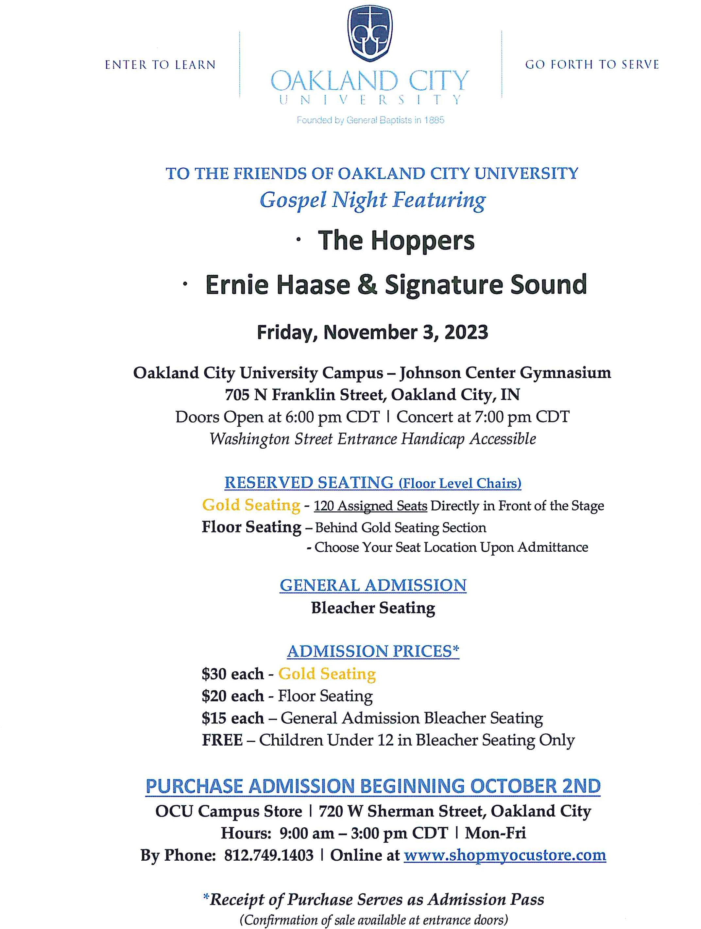

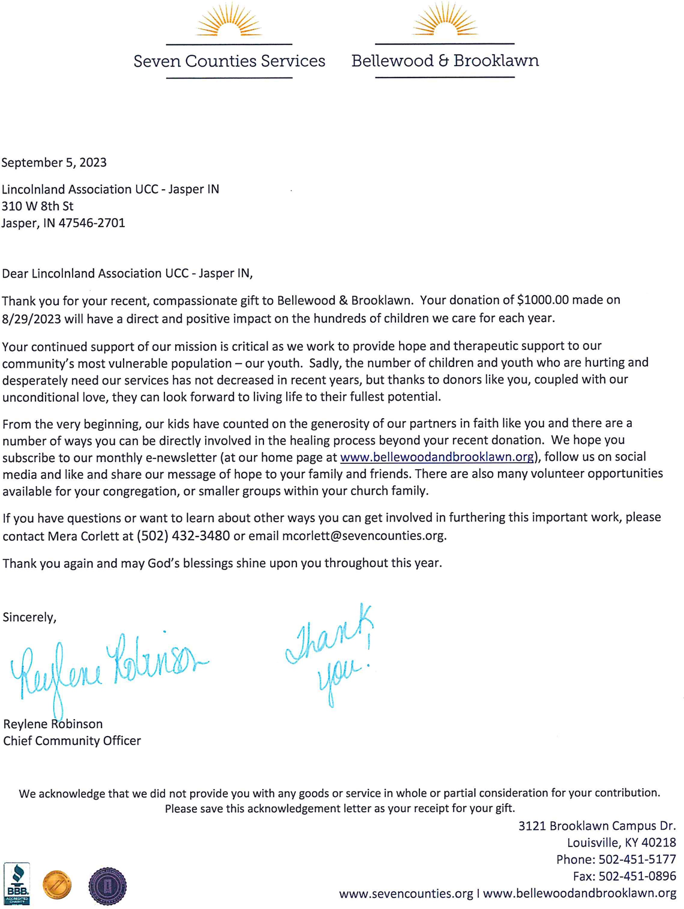

 **Christmas Poinsettias**

It’s that time of year again to honor or remember our friends and loved ones with the purchase of a poinsettia plant to be used in decorating our sanctuary. The price has decreased to $13 each.

Poinsettia order forms are available in the entrance, with this newsletter or attached to this email. Forms and payment may be placed in collection box outside the sanctuary doors or in the collection box outside the church office. Plants will be available to take home after the Christmas Eve service or anytime following.

**Cost is $13 per plant. All orders must be placed by Monday, December 11th.**

Let's keep our sanctuary festive!

**Poinsettia order form - $13 each**

I/we ______________________________ would like to order ___________ poinsettia plant/s for decorating of the sanctuary. Please make my donation $_______________.

In memory of _________________________________________________________.

OR

In Celebration of _______________________________________________________.

Money enclosed $_______________. All orders must be placed by December 11th.



**October 2023 - Worship Participants**

**October 1st - Eighteenth Sunday after Pentecost**

**Bible Readers:** Lisa Schmidt

**Organist:** Sarah Sergesketter **Special Music:** Gather & Sing Choir

**Time with Young Disciples:** Heather Goodhue

**Media Producer:** Doreen Lechner **Media:** John Kahle **Usher & Lock-up:** Phil & Lisa Schmidt

**Communion Prep:** John & Janis Schnarr

**October 8th - Nineteenth Sunday after Pentecost**

**Bible Readers:** Sarah Sergesketter

**Organist:** Sarah Sergesketter **Special Music:** Duet: Alexander Thomas & Kay Hall

**Time with Young Disciples:** Casey Uebelhor

**Media Producer:** Kurt Vonderheide **Media:** Mark Blackgrave

**Usher & Lock-up:** Dan and Sarah Sergesketter

**October 15th – Twentieth Sunday after Pentecost**

**Bible Readers:** Pamela Catt

**Organist:** Sarah Sergesketter **Special Music:** Gather & Sing Choir

**Time with Young Disciples:** Heather Goodhue

**Media Producer:** Nichole Lechner **Media:** Nichole Lechner  **Ushers & Lock-up:** Pamela Catt

**October 22nd – Twenty-First Sunday after Pentecost**

**Bible Readers:** Mary Ann Weisheit

**Organist:** Sarah Sergesketter

**Time with Young Disciples:** Pastor Karen Fraser Moore

**Media Producer:** Mark Blackgrave **Media:** Adam Roth

**Ushers & Lock-up:** Alexander Thomas

**October 29th – Twenty-Second Sunday after Pentecost**

**Bible Readers:** David Hubster

**Organist:** Sarah Sergesketter

**Time with Young Disciples:** Heather Goodhue

**Media Producer:** Doreen Lechner **Media:** Kurt Heise

**Ushers & Lock-up:** David Hubster

**9:00 AM USHERS (Lock Up) and SCRIPTURE READERS**

**Ushers and Lock Up Scripture Readers**

**October**

**10/1 Phil & Lisa Schmidt Lisa Schmidt**

**10/8 Dan & Sarah Sergesketter Sarah Sergesketter**

**10/15 Pamela Catt Pamela Catt**

**10/22 Alexander Thomas Mary Ann Weisheit**

**10/29 David Hubster David Hubster**

**November**

**11/5 Selena Vonderheide Kurt & Selena Vonderheide**

**11/12 Roth Family Karsen Roth**

**11/19 Cindy Howard Doug Bawel/Suellen Seng**

**11/26 Judy Hubster Heather Goodhue**

**11/26 John & Susan McGovren Susan McGovren**

**December**

**12/3 John Schnarr Family Dan Sergesketter**

**12/10 John Kahle John Kahle**

**12/17 Greg Schnarr & Family Greg Schnarr**

**12/24 No Morning Service**

**12/31 Pamela Catt Mark Blackgrave**

**October Birthdays**

**Name Date**

|  |  |  |
| --- | --- | --- |
| Sarah | Blackgrave | 2 |
| Grant | Blackman | 5 |
| Chloe | Premuda | 7 |
| Julie | Beck | 7 |
| Fred | Robberts | 8 |
| Janice | Sunderman | 8 |
| Julie | Schroeder | 10 |
| Reid | Cole | 14 |
| Trystan | Armstrong | 14 |
| Heather | Goodhue | 15 |
| Corma | Knebel | 15 |
| Mike | Mehling | 15 |
| Dean | Vonderheide | 15 |
| Haley | Wright | 16 |
| Carter | Beamon | 16 |
| Vickie | Campbell | 17 |
| McKenzie | Blackman | 18 |
| Peyton | Blackgrave | 19 |
| Jerry | Adams | 21 |
| Ann | Berg | 22 |
| Larry | Schnell | 24 |
| Brian | Meyer | 25 |
| Bryent | Roth | 26 |
| Harley | Hopster | 31 |

**October Anniversaries**

**Name Date Years**

Sarah & Tom Hopf 10/10/1970 53

Mike & Linda Mehling 10/11/1969 54

Jeff & Toni Miller Eichmiller 10/19/2013 10

Mark & Paula Marshall 10/21/2017 6

Dr. Harland & Lelani Wittwer 10/23/1965 58

Jeremy & Rachel Lindauer 10/25/2014 9

Kathy & Victor Danford 10/29/1988 35