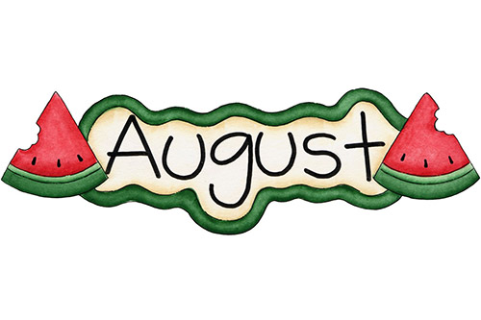**Trinity United Church of Christ**



***August 2023***



***Worship: 8am & 10:15am***

**------------------------------------------------------------------------------------------------------------------**

**August 6th –** Matthew 14:13-21 “More Than Enough”

**August 13th –** Matthew 14:22-33

“How to Walk on Water”

**August 20th –** Pastor Karen Fraser Moore will be away. Someone will be here to fill the Pulpit for her.

**August 27th –** Matthew 16:13-20 “What’s My Line?”

**Communion: Please pick up your communion wafer & cup as you enter the sanctuary.**

**Offering: Please place your gifts in the offering box as you enter or leave worship.**

**Contact Information**

**Pastor: Rev. Karen Fraser Moore**

welwoman@hotmail.com, 618.920.3592

**321 W. 8th Street … Jasper, Indiana 47546**

(Corner of Clay & 8th Street)

**Mailing Address:** PO Box 386

Jasper, Indiana 47547-0386

**Office Administrator**: Taylor Popp

**Office Phone:** 812-482-4090

**Office Hours:** Monday, Wednesday & Thursday

9am – 1pm & 2pm - 3pm

**Website:** htps://www.trinityjasperucc.org

**Monthly Calendar**

**W 2** 7:00 pm AA Meeting

**F 4** 10:15am Mommy & Me Playgroup

7:00 pm AA Meeting

**SU 6** 8:00 & 10:15 am Worship ~ Communion

**W 9** 6:00 pm Worship Team Meeting

7:00 pm AA Meeting

**F 11** 7:00 pm AA Meeting

**M 14** 5:00 pmCE Team Meeting

7:00 pm Council Meeting

**W 16** 7:00 pm AA Meeting

**F 18** 10:15am Mommy & Me Playgroup

7:00 pm AA Meeting

**SU 20** *Pastor Karen will be away.*

8:00 & 10:15 am Worship

**T 22** ***Newsletter Articles Due***

4:00 pm Sunset Extension

**W 23** 7:00 pm AA Meeting

**F 25** 7:00 pm AA Meeting

**SU 27** 8:00 & 10:15 am Worship

**M 28 *Newsletter Sent***

**T 29** 1:00 – 6:00 pm Blood Drive (Parish Hall)

**W 30** 7:00 pm AA Meeting

**Karen’s Kares**

It has already been a busy summer and in a few short weeks we will be back into the rhythm of a new school year and regular monthly team meetings. **It has been approved by Council that all of our Teams have Co-Chairs as we prepare for 2024 and that all Teams prepare documents that detail the purpose and work of each team as we enter 2024**. These actions will help us prepare a set of By-Laws to accompany the current Constitution. This type of preparatory work will be greatly appreciated and extremely useful for your new pastor. In the meantime, here are some highlights of work Trinity Teams have been doing behind the scenes.

Our **Outreach Team** has compiled an extensive notebook outlining each of the special offerings and other generous programs this team supports and promotes within our congregation almost on a monthly basis. It is well done and will be very valuable as this team continues to reach out beyond the walls of our building to be a witness to people in need.

Our **Christian Education Team** is ready to begin preparing to lead an educational experience for elementary school children which will occur at the middle school this fall. This team intends to design modules that will provide children with opportunities to explore a Bible Story, including Music, Crafts, Drama, and other creative endeavors. This team hopes this program can rebuild an interest among the children of this community to learn about Jesus, God and the Bible. Anyone willing to be a second adult to assist the leader is encouraged to let any of the Christian Education Team know of your willingness to provide support and an extra set of hands.

A group of **19 leaders gathered** to be part of our involvement in the **Dubois County 2023 Pride Festival.** During that event, we were able to gather contact information from a number of people to create a database of adults and children which we can personally invite to worship and to participate in other activities. Almost all of those leaders participated in a variety of ways on the day of the Festival to show our desire as a congregation to be inclusive and welcoming. I am in the midst of considering ways to involve some of those who were so supportive to consider **becoming a Hospitality Team for the congregation**.

**The Bridge Team** has posted sheets in the Narthex for all members of the congregation to sign up to participate in small group Listening Sessions about the future ministries of Trinity. The Listeners at these small group meetings will be one member of the Bridge Team and one member of the Church Council. The “talkers” at these small group meetings will be those who attend worship. These meetings are an opportunity to dream, share ideas, consider new opportunities and welcome new initiatives. I pray you will all sign up to take part in sharing your vision of Trinity’s Future.

This month the **Media Team** will be receiving quotes from a few vendors about the purchase of equipment to record and stream our worship services. Stay tuned for updates in a few weeks.

In Christ’s Love and Kare, *Pastor Karen*

**Church Bridge Team Status Report - July 2023**

Introduction: Our Congregation’s Bridge Team (Mark Blackgrave, Alexander Thomas, Audra Jahn, Heather Goodhue, John Kahle, Adam Roth, and Mary Ann Schroeder) has been working diligently over the last months under the coaching of Pastors Karen and Paul, and utilizing a bridge team process framework developed the Indiana Kentucky Conference. The process is very deliberate and intentional (and may sometimes seem long) but the goal is to provide a comprehensive and “fact-based” description of Trinity Church and the surrounding community to develop an accurate Congregational Profile to begin the pastoral search process to obtain the best match for a new pastor. The work has included congregational surveys, community leader interviews, demographic studies, and the development of values, mission, and vision statements. The purpose of this report is to present the status of the team's progress and highlight key findings.

1. Survey Results: A congregational survey was conducted to gather feedback from folks who regularly attend worship. The survey received a limited number of responses. Key findings from that survey include:

a. Importance of Community: Respondents expressed a strong desire for the church to actively engage with the local community and foster a sense of belonging.

b. Worship Preferences: The survey revealed a range of preferences regarding worship styles and formats, indicating a need for flexibility and inclusivity.

c. Outreach and Social Services: Respondents highlighted the importance of community outreach and social service initiatives, expressing a desire for the church to make a positive impact beyond its walls.

1. Community Leader Interviews: Interviews were conducted with prominent community leaders in various areas (law enforcement, health care, chamber of commerce, schools, and community foundation) to gain insights into the church's reputation and opportunities for collaboration. Key findings from the interviews include:

a. Reputation: The church is recognized for its outreach and community involvement.

b. Collaboration Opportunities: Community leaders expressed a willingness to collaborate with the church on various initiatives, particularly those related to homelessness, substance abuse and mental health.

1. Demographic Studies: The Conference provided demographic and religious belief studies covering our local area as reflected in the Midwestern region of the U.S. The studies revealed the numerous insights, including:

a. Changing Demographics: The area has experienced demographic shifts, including an increase in young families and a growing multicultural population.

b. Socioeconomic Factors: The studies indicated pockets of economic disparity within the community, highlighting the need for targeted outreach and support programs.

c. Beliefs: The studies showed a somewhat negative trend in church participation and church organizations, indicating a need for inclusivity and understanding.

1. Development of Values, Mission, and Vision Statements: The Church Bridge Team has actively worked on developing values, mission, and vision statements that reflect the aspirations and priorities of the congregation and align with the community's needs. The Values Statement was recently shared, and the Mission and Vision Statements drafts have just been completed.
   1. Values: The team has identified key values which can guide the church's activities and decision-making processes.

“At Trinity United Church of Christ, we believe that God is still speaking and strive to be a welcoming and open community of faith. We hope to provide a safe and inclusive space where people of all backgrounds and identities can come together to worship, learn, and grow in their faith. We celebrate diversity and the richness that comes from our differences and believe that everyone has something valuable to contribute to our church family. We are committed to creating a culture of love, compassion, and acceptance, and we welcome all who seek to join us on this journey.”

* 1. Vision Statement: The vision statement envisions the church as an active and inclusive community.

“An inclusive community of faith, passionately serving God with hope, confidence and peace.”

* 1. Mission Statement: The mission statement is intended to be a very concise, easy-to-remember statement, focused on action.

“God Speaks. We Serve.”

Next Step: The Church Bridge Team has made significant progress and we are in the home stretch. To complete our work, we need to be sure our congregation is comfortable with the results in order that a Congregational Profile can be completed which we can represent is fully supported by our congregation. To do this, we will be scheduling small group discussion meetings to discuss the findings and gather feedback. The Bridge Team would be very appreciative of your participation in one of those meetings. Thank you.

**GUIDELINES FOR SMALL GROUP MEETINGS**

**SOME IMPORTANT BACKGROUND INFORMATION**

**How the Indiana Kentucky New Transition Process Began**

In 2021, a group of clergy began meeting with IKC Associate Conference Minister, Monica Ouellette, to discuss and then create a more appropriate framework for a congregation to follow before entering into a search process for a new pastor. Previously, in many instances, when a congregation was in transition, the search team would pull out the Congregational Profile that was circulated the last time the congregation was searching for a new pastor, briefly update it and then place it back in circulation without much thought or discussion as to how the congregation or the culture may have changed during the last pastorate. Those clergy formed the IKC Transitions Team and began to build a new framework, which included each congregation calling a Transitional Pastor along with a Bridge Coach for the congregation’s Bridge Team.

The Bridge Team Framework focuses on various exercises to help the Bridge Team respond to three (of four) questions before a search team is appointed and a search process for a new pastor begins. *(The fourth question – “What kind of pastor will our congregation need to call in order to respond to God’s Preferred Future for the congregation will be answered by the Search Team.)*

**The three questions are:**

1. **Who Are We?**
2. **Who Are Our Neighbors?**
3. **What is God calling us as a congregation to do to provide needed ministries to our neighbors? What needs/issues exist within the community which need to be addressed? (i.e., homelessness; poverty, hungry children, abuse, addiction, etc.)**

**QUESTION ONE – WHO ARE WE?**

Please describe our congregation using five or less adjectives.

In your opinion, what is the Trinity UCC congregation best known for in Jasper and in the surrounding community?

**QUESTION TWO – WHO ARE OUR NEIGHBORS?**

From a Biblical and spiritual standpoint, what is an appropriate description of neighbor?

*(The second is this, ‘You shall love your neighbor as yourself.’ There is no other commandment greater than these. Mark 12:31 (NRSV))*

What type of ministries is Trinity UCC presently providing for our neighbors?

What additional ministries could Trinity UCC provide for or to our neighbors?

**QUESTION THREE**

**WHAT IS GOD CALLING OUR CONGREGATION TO DO and BE; AND TO BECOME?**

What purpose do you believe Trinity UCC serves?

How do believe / feel Trinity UCC could better serve Jasper and the surrounding community?

If you could create the perfect congregation, how would you describe it? How and where would it focus its time, energy, strengths and finances?

**Additional Questions that relate to the future of Trinity UCC**

Back in the 1980’s the congregation decided to have two worship services to address the need for additional parking. There was not enough street parking at the time to accommodate the average Sunday morning attendance. The congregation now has three parking lots (plus street parking) and the 8:00 am worship service has a low attendance (with an average of 10 to 12 most Sunday’s). The congregation’s leadership believes it may be time to now hold only one worship each Sunday. The most challenging decision to return to one worship service is the question of when.

In your opinion, which of the following worship times would draw the most people on an average weekly Sunday morning:

9:00 am 9:30 am 10:00 am 10:15 am

Another conversation that is occurring among leadership is whether our congregation should enter the outlined process (of about 2 years) to officially become **“An Open and Affirming”** **(O N A)** **Congregation** which welcomes and readily accepts all persons, regardless of race, economic status, sexual orientation or lifestyle.

What type of conversations do you believe would help our congregation become ready to consider entering this process?



**Corrine Clark** *Legacy Living, 1850 IN-56, Rm. # 202 (812-482-3482)*

*Jasper, IN 47546*

**Sherry Malone** *660 Rumbach Ave. Apt. #322 (812-582-2721)*

*Jasper, IN 47546*

**Claire Rohleder** *Legacy Living, 1850 IN-56, Rm. # 220 (812-482-3185)*

*Jasper, IN 47546*

**Violet Ruckriegel** *Scenic Hills, 710 E Sunrise Dr. Rm. # 503 (812-504-2578)*

*Ferdinand, IN* *47532*

**Alene Frank** *Good Samaritan Society (Garden Ridge) (812-482-1722)*

*2515 Newton Street*

*Jasper, IN 47546*

**Shirlene Dreher** *St. Charles Health Campus, 3150 St. Charles Street (812-634-5670)*

*Jasper, IN 47546*

**Linda Troxler** *Legacy Living, 1850 IN-56, Rm. # 237 (812-556-3196) Jasper, IN 47546*

**Janice Sunderman** *1850 W State Road 56, Apartment 134* *(812-559-0560)*

*Jasper, IN 47546*



**Jack Astrike**, the son of Bret and Neil Astrike, passed away on July 25th, 2023.

A visitation for Jack will be held at Trinity UCC on Friday, July 28th, from 10am-12pm with a service at 12pm. There will be a luncheon following the burial at 1:30pm.



**Pray without ceasing…**

* Pray for ALL in need of healing; may God grant them strength and patience.
* Pray for those impacted by the devastations from wind, fire & water.
* Pray for those families and communities where the young and elderly have been killed by senseless violence in various places in our country, including children in schools, those getting groceries, and those attending worship.
* Pray for our military, first responders and those in law enforcement.

**Mission Alive at Trinity**



**Adopt a Family: Year-to-date** we have collected **$1,702.05**

This year’s family is a single dad and his middle school son. They have given their permission for us to share a bit of their history with you.Both parents were together when the boy was young, but Mom eventually moved to Texas with him because Dad was struggling with drugs and had spent some time incarcerated. Dad has overcome his past issues and has been able to stay away from drugs for 5 years now!!! A job brought him to the southern Indiana area and he settled in Jasper. Recently, Mom notified him and indicated she did not feel capable of raising their adolescent son. The child also has been diagnosed with autism, so there are challenges besides the “usual” pre-teen issues. She wanted to send him to Jasper to live with Dad, who was eager for the chance to be with his son full-time. He is a great kid who enjoys school, Legos and drawing. They have enjoyed their time together, and Dad is determined to provide a safe, comfortable and loving home for them both.

We appreciate your continued change jar support of our new family. Please remember them in your prayers, as well. We feel confident Trinity’s generosity will make 2023 a wonderful year for them!

With gratitude, The Outreach Team

**Food Bank**

These items were donated by the Trinity family since the last newsletter: 6 boxes of mac & cheese, 30 cans of fruit, 1 large bag of cereal, 1 bottle of shampoo, 1 bottle of dish washing soap

**In addition to the rising cost of groceries, children were home eating extra meals this summer. Your help with groceries for those in need is appreciated!**



**August items:  cereal and oatmeal**

**Mission Alive at Trinity**

**COLLEGE ADDRESSES NEEDED**

If you are a parent of a college student, please send the church office your child's college address. We will be mailing a greeting to them in October. Thank you!

**DUBOIS COUNTY PRIDE**

Thank You Letter:

Thank you for your support as a sponsor for the 2023 Dubois County PRIDE! Festival. It means the world to us. Your generosity has made a significant impact on creating an inclusive and empowering event for the LGBTQT Community. We are truly grateful!

~ Dubois County PRIDE Board and Festival Committee



**Date Worship Attendance**

**July 2**  10:15am 42 **Total 42**

**July 9** 8:00am 14 10:15am 41 **Total 55**

**July 16** 8:00am 18 10:15am 51 **Total 69**

**July 23** 8:00am 13 10:15am 47 **Total 60**

**WOMEN’S GUILD**

The 2023-2024 Guild year will start on Sunday, September 10th. The meeting will be held at 9am in the Chapel Room. We will be having a service in memory of those women of Trinity that have passed away in the last two years. Watch the September Newsletter for activities planned for the rest of the year. Thank you! ~ Judy Hubster

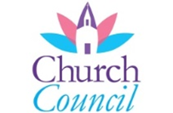

**June Council Highlights**

|  |  |  |
| --- | --- | --- |
| **July Council Decisions:** | | |
| **- Approval was given for:** | |
| **No decisions were made for the month of July.** |

**The next Council Meeting will be held on August 14th at 7:00pm.**

**YEAR-TO-DATE 2023 FINANCIAL REPORT**

*Expenses*

January-June $107,367

Budget $114,879

(underspent budget by $7513)

*Contributions*

January-June $91,513

Budget $94,748

By comparison

Year-to-date 2022 giving was $79,539

Year-to-date 2021 giving was $85,578

**THANK YOU!**

**A special THANK YOU to Melissa Blackgrave, James Goodhue, and Casey Uebelhor for enriching our worship services in July.**

We are looking for singers to join the Gather and Sing choir in September. Please consider sharing your musical talent. Please call, Sarah Sergesketter with any questions. (812) 482-5578

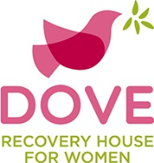

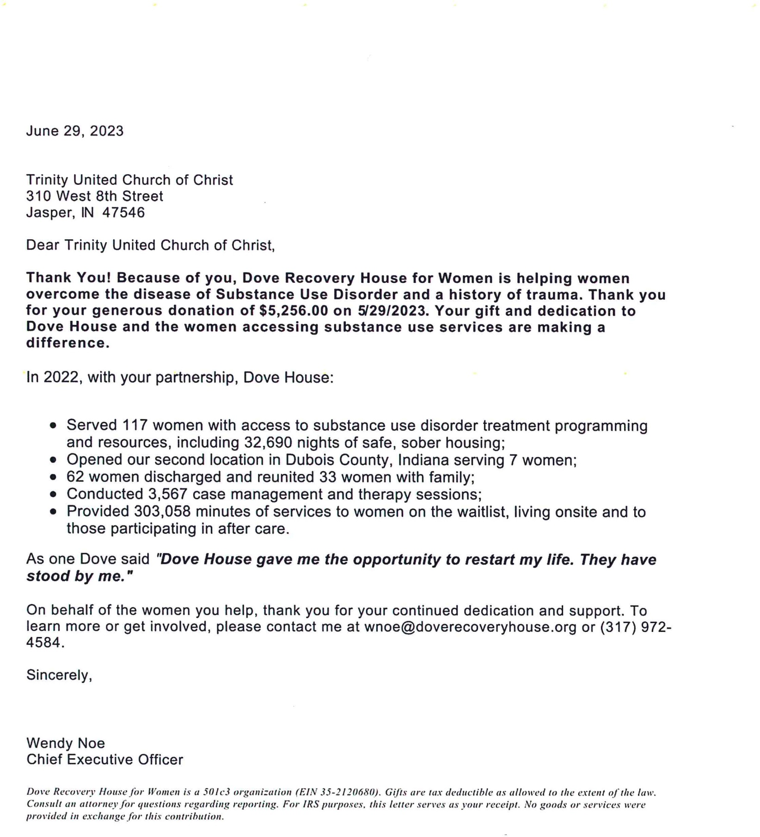

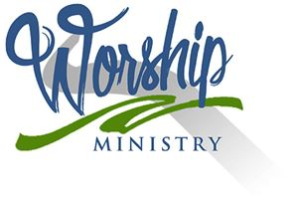

**August 2023 - Worship Participants**

**August 6th – Tenth Sunday after Pentecost**

**Bible Readers:** Bill Small, Casey Uebelhor

**Organist:** Mary Ann Weisheit, Sarah Sergesketter

**Time with Young Disciples:** Pastor Karen Fraser Moore

**Media Producer:** Doreen Lechner **Media:** Kurt Vonderheide, Mark Blackgrave

**Usher:** Bill Small

**Usher & Lock-up:** Larry LaGrange

**Communion Prep:** Susan McGovren

**August 13th – Sixth Sunday after Pentecost**

**Bible Readers:** Doug Bawel & Suellen Seng, Heather Goodhue

**Organist:** Mary Ann Weisheit, Sarah Sergesketter

**Time with Young Disciples:** Casey Uebelhor

**Media Producer:** Kurt Vonderheide **Media:** Kurt Vonderheide, Nichole Lechner

**Usher:** Doug Bawel & Suellen Seng

**Usher & Lock-up:** Judy Hubster

**August 20th - Twelfth Sunday after Pentecost**

**Bible Readers:** Mary Ann Weisheit, Greg Schnarr

**Organist:** Mary Ann Weisheit, Sarah Sergesketter

**Time with Young Disciples:** Heather Goodhue

**Media Producer:** Nichole Lechner **Media:** Mark Blackgrave, Adam Roth

**Usher:** Mary Ann Weisheit

**Ushers & Lock-up:** Greg Schnarr and Family

**August 27th - Thirteenth Sunday after Pentecost**

**Bible Readers:** Connie Schmitt,John Kahle

**Organist:** Mary Ann Weisheit, Sarah Sergesketter

**Time with Young Disciples:** Pastor Karen Fraser Moore

**Media Producer:** Mark Blackgrave **Media:** Kurt Vonderheide, Kurt Heise

**Usher:** Connie Schmitt

**Ushers & Lock-up:** John Kahle

**August Birthdays**

**Name Date**

|  |  |  |
| --- | --- | --- |
| Gary | Frank | 6 |
| Linda | Troxler | 7 |
| Brooklyn | Whitecotton | 8 |
| Kim | Schroeder | 9 |
| Leesa | Beyke | 10 |
| Mary | Klingel | 10 |
| Mark | Blackgrave | 11 |
| Debie | Stockburger | 11 |
| Lucas | Hobson | 12 |
| Kelsey | Blackgrave | 12 |
| Sheila | Oeding | 13 |
| Brian | Ferrell | 13 |
| Jason | Hulsman | 14 |
| Caroline | Kahle-Mattingly | 14 |
| Russ | Giesler (Schroeder) | 15 |
| Sarah | Mauck | 18 |
| Jeff | Steffen | 18 |
| Pamela | Catt | 21 |
| Cindy | Denu | 21 |
| Cortney | Seng | 24 |
| Sydney | Berger | 24 |
| Mary Ann | Schroeder | 25 |
| Mary Beth | Brozman | 26 |

**August Anniversaries**

**Name Date Years**

Rebecca & Eddie Armstrong 8/6 unknown

Larry & Jenny LaGrange 8/23 54

Brian & Janet Meyer 8/29 42

Sheila & Terry Oeding 8/29 14