Trinity United Church of Christ
March 2023

Worship: 8am & 10:15am

------------------------------------------------------------------------------------------------------------------

MARCH 5 – “Nick at Nite”
John 3:1-17

MARCH 12 – “That Day at the Well”
John 4:5-42

MARCH 19 – “Too Blind to See”
John 8:1-41

MARCH 26 – “But It will Stink!”
John 11:1-45

Communion: Please pick up your communion wafer & cup as you enter the sanctuary.

Offering: Please place your gifts in the offering box as you enter or leave worship.

Contact Information
Pastor: Rev. Karen Fraser Moore
welwoman@hotmail.com, 618.920.3592

321 W. 8th Street … Jasper, Indiana 47546
(Corner of Clay & 8th Street)
Mailing Address: PO Box 386
Jasper, Indiana 47547-0386

Office Administrator: Taylor Popp
Office Phone: 812-482-4090
Office Hours: Monday – Thursday
9am – 1pm & 2pm - 3pm

Website: htps://www.trinityjasperucc.org
March Monthly Calendar
W 1 6:30 pm SHAPE
SA 4 10:00 am Music Together
SU 5 Communion
8:00 & 10:15 am Worship
9:45 am Gather & Sing Choir
6:00 pm Tech Team
M 6 10:00 am Music Together
2:30 pm Prayer in the Sanctuary
7:00 pm Worship Team
W 8 6:30 pm SHAPE
SA 11 10:00 am Music Together
SU 12 8:00 & 10:15 am Worship
9:00 am Women’s Guild
9:00 am Men’s Fellowship
M 13 10:00 am Music Together
2:30 pm Prayer in the sanctuary
7:00 pm Council Meeting
W 15 6:30 pm SHAPE
SA 18 10:00 am Music Together
SU 19 8:00 & 10:15 am Worship
9:45 am Gather & Sing Choir
M 20 Newsletter Articles Due
2:30 pm Prayer in the Sanctuary
T 21 4:00 pm Sunset Extension
W 22 NO CONFIRMATION (Spring Break)
6:30 pm SHAPE
SU 26 8:00 & 10:15 am Worship
2:00 pm Outreach Meeting
M 27 2:30 pm Prayer in the Sanctuary
W 29 6:30 pm SHAPE
TH 30 Newsletter Sent

The church office is closed every Friday!

March Weekly Calendar

AA – Wednesdays & Fridays @ 7:00 pm
Sunday School – Sundays @ 9:00 am
Confirmation – Wednesdays @ 4:45 pm
Karen’s Kares
As our congregation enters the Lenten Season, I am continuing to notice a lack of understanding that this “Transition” process is a new approach to the ways congregations previously completed a Congregational Profile and then received Ministerial Profiles from candidates desiring a new congregation to serve.

For several decades, some congregations hurried through the “Search Process” without realizing they were not the same congregation they had been during the tenure of former pastor. Depending upon the length of the former pastor’s term of service, whether we want to admit it to not, many changes have occurred in our society, our culture, our communities, our world and our lives. Family transitions, employment changes, economic changes, technological advances, to name only a few. Basically, as human beings, we are almost always living in some sort of transition.

When congregation does not take the time needed to discern the changes that have occurred in and all around them and proceed to quickly call a new pastor without considering whether she/he/they will be a good match for the challenges of their present congregation, the result can be an “un-intentional interim,” a congregational conflict, or simply an tension filled, unhappy atmosphere that can keep the congregation from growing spiritually or numerically.

In the past two plus years, I have been serving on the IKC Transitions Team to help create a new approach to working through a transitional process within a congregation. Rather than hurriedly completing a Congregational Profile without any discernment, the new approach is to create a “Bridge Team” within the leadership to work through questions in order to understand: Who is the Congregation Now? Who are our neighbors? What is God’s Preferred Future look life for our congregation? What is God calling our congregation to do in our community? Finally, what type of pastoral leader can best lead our congregation to follow God’s Preferred Future for us?

The Bridge Team of our congregation has begun to explore various ways to respond to these questions. The process will probably take several more months, especially since the Bridge Team wants to make every possible effort to include the perspectives of the members of our congregation in responding to the above questions. Only after the Bridge Team has worked through all the steps outlined in the Transitional Framework, will a Search Team be called together to begin the process of assembling a Congregational Profile. However, if the Bridge Team has completed its work well, taking the time needed to do so without being rushed, then a good portion of the information needed to complete the Congregational Profile will have already been pulled together.

The people of Trinity have already shown great patience over the past 8 months. However, I pray the members and friends of Trinity will continue to exercise patience, and unwaveringly faith to believe in the important work the Bridge Team is doing, and come to understand that by supporting their work with prayer, when the time comes to begin an actual Search Process, it will be smooth sailing. There is so much potential within the Trinity congregation! It is vitally important for all of us to allow God’s Holy Spirit to be at work in our midst, leading us toward a new and exciting future. We will get there together!!! Prayer is the Answer!!

In Christ’s Love and Kare, Pastor Karen
March Council Highlights

February Council Decisions:
- Approval was given for:
- allocating $200 to replace the altar candles with liquid candles

- spending up to $2,000 from the In and Out Maintenance Fund to cover the cost of having the elevator company on-site during the replacement of the faulty sump pump

- allocating up to $450 to cover IT upgrades and needed updates

- Susan McGovren and David Hubster as signers for the safety deposit box

- allowing Mothers of Preschoolers to use the Trinity Tree House classroom areas and the Parish Hall for an indoor play space in exchange for a donation

The next Council Meeting will be held on March 13th at 7:00pm.

Trinity UCC is thrilled to welcome new members to our Church family!

New members include: Wes Dellihay, Barbara Dellihay and Anthony Price (and family). If you see them around, please introduce yourself and make them feel welcomed!

If you would like to become a member of Trinity UCC, please call or email the church office
for more information!

TRINITY EASTER EGG HUNT!

We are so excited to announce that Trinity UCC will again host an Easter Egg Hunt!

In order for this event to be successful, we are in need of candy donations.
If you are able, please place your candy donations in the basket in the Narthex
and be sure to label it “Easter Egg Hunt”. Thank you!

If you have any questions, please call the Trinity Church office at (812) 482-4090.

Jack Astrike 4213 Baden Strasse, (812-634-7920)
Jasper, IN 47546

Corrine Clark Legacy Living, 1850 IN-56, Rm. # 202 (812-482-3482)
Jasper, IN 47546

Mariemma Huebner Northwood Retirement Community, Assisted Living (812-634-7945)
400 Pleasant View, Apt. # 23
Jasper, IN 47546

Sherry Malone 660 Rumbach Ave. Apt. #322 (812-582-2721)
Jasper, IN 47546

Claire Rohleder Legacy Living, 1850 IN-56, Rm. # 220 (812-482-3185)
Jasper, IN 47546

Violet Ruckriegel Scenic Hills, 710 E Sunrise Dr. Rm. # 503 (812-504-2578)
Ferdinand, IN 47532

Janice Sunderman Legacy Living, 1850 IN-56, Rm. # 134 (812-556-3196)
Jasper, IN 47546

Alene Frank Good Samaritan Society (Garden Ridge) (812-482-1722)
2515 Newton Street
Jasper, IN 47546

Others to keep in thought and prayer…

- Shirlene Dreher, David Fischer and Brian & Sandy Ferrell

Pray without ceasing…

- Pray for the people of Ukraine and give thanks for all who are welcoming refugees.

- Pray for ALL in need of healing; may God grant them strength and patience.

- Pray giving thanks that the Covid-19 numbers continue to fall, remembering that there are still those who are losing their lives. We give thanks for our health care workers!

- Pray for those impacted by the devastations from wind, fire & water.

- Pray for those families and communities where the young and elderly have been killed by senseless violence in various places in our country, including children in schools, those getting groceries, and those attending worship.

- Pray for our military, first responders and those in law enforcement.
Mission Alive at Trinity

Adopt a Family: Year-to-date we have collected $227.55

This year’s family is a single dad and his middle school son. They have given their permission for us to share a bit of their history with you. Both parents were together when the boy was young, but Mom eventually moved to Texas with him because Dad was struggling with drugs and had spent some time incarcerated. Dad has overcome his past issues and has been able to stay away from drugs for 5 years now!!! A job brought him to the southern Indiana area and he settled in Jasper. Recently, Mom notified him and indicated she did not feel capable of raising their adolescent son. The child also has been diagnosed with autism, so there are challenges besides the “usual” pre-teen issues. She wanted to send him to Jasper to live with Dad, who was eager for the chance to be with his son full-time. He is a great kid who enjoys school, Legos and drawing. They have enjoyed their time together, and Dad is determined to provide a safe, comfortable and loving home for them both.

When contacted about becoming our new Adopt-A-Family, he was overwhelmed. It will help him to continue “to climb his way out of the hole” (his words) he created for himself. He has much gratitude for our kindness. Already, we have provided Christmas gifts for both Dad and son (they say THANKS!!) plus the January change jar gift, a $150 gift card to IGA to be used for groceries and/or gas.
We appreciate your continued change jar support of our new family. Please remember them in your prayers, as well. We feel confident Trinity’s generosity will make 2023 a wonderful year for them!
With gratitude, The Outreach Team

Food Bank!
Since the February Newsletter, people of Trinity have donated: 18 rolls of toilet paper, 20 bags/
boxes of pasta, 17 jars/cans of pasta sauce and plastic bags

All of us are struggling with paying more for groceries these days. Thank you for these donations. The need in our community is greater than ever!

March item: Hamburger and Tuna Helper

Blankets of Love
Our mission for February was Blankets of Love sponsored by Church World Services.
Our goal was $400 (40 blankets). We surpassed that goal by $450 donated!
Thank you for your donations!
Lenten Mission – Dove House

Imagine having a sister, daughter, daughter-in-law, or granddaughter who was addicted to drugs or alcohol. How could you help her? Could you help, or would you need outside assistance?
Actually, us urging our loved ones to stop doing drugs or drinking and expecting them to stop is pretty unlikely. Even if she were to get arrested for this, the arrest probably would not cause her to stop.
Addiction is a disease. People who are addicted cannot just "stop" most of the time. They need help--counseling and support. Those who have been addicted for some time usually have created other issues, such as losing their job, experiencing school or marital problems, losing housing, having their children removed from them, etc.
With all of the difficulties that often happen to a person who has an addiction problem, simple fixes are not usually effective. Long term, intense therapies and interventions are needed. These are expensive. Often the home setting is part of the problem with which the lady is dealing.
We learned about Dove House when Megan Durlauf spoke at the February 19th services at Trinity and explained the importance of removing the obstacles of housing and money from the recovery process of addicts. When their mind is free from those worries, they can focus on healing themselves. It would be similar to being in a hospital and being fed and taken care of.
The women of Dove House have chores to do and conduct to be responsible for, but Dove House does not charge them for their stay or the services they receive. Dove House receives grants and donations in order to make this program possible.
Please help these women who are residents to heal. You can help someone's child regain her life and help our community have contributing citizens. We hope that you will be moved to help us surpass our goal of $5,000 for this Lenten Mission. Thank you!

February Worship Attendance

Date Worship Attendance

February 5 8:00am 13 10:15am 48 Total 61
February 12 8:00am 13 10:15am 47 Total 60
February 19 8:00am 14 10:15am 47 Total 61
February 22 Ash Wednesday 7:00pm Total 45
February 26 8:00am 14 10:15am 51 Total 65

Women’s Guild

Thanks to those who brought items for the breakfast on February 12th. It was an enjoyable time of visiting with everyone.

Sunday, March 12th at 9:00am – Guild will assemble the hygiene kits for Church World Service. Thanks to everyone who brought items in for these kits.
Sunday, April 9th – Easter Breakfast – We are looking forward to the tasty casseroles and breads!
Sunday, April 16th at 9:00am – We will be meeting the third week this month due to Easter falling on the second week. Please join us as we finalize plans for our Spring Celebration with Augustana and St. Paul.

Don’t forget that Prayer Shawls are needed for General Synod this summer. They may be brought to the Church office labeled “General Synod” or given to a Guild member. Thank you!

We are excited to announce Trinity UCC will offer the “Heart Saver CPR with AED” Class on Tuesday, March 28th, 2023, from 5:30 pm to 8:30 pm. Certification is available. The cost will be $30 per person for certification and $5.00 for Family and Friends. Instructors will be Marsha Hill and Laurie Baker.
We will meet at the Church in either the Chapel Room or Parish Hall (yet to be determined).
Please invite your family members and friends to take advantage of this important life-giving, life-saving opportunity. Thank you.
Worship Team Request
A new addition to our services is the availability of a microphone when Worship participants share announcements, joys and concerns. The mic not only allows Pastor Karen to hear but also the others in the congregation.
It is the hope of both the Worship Team and the Church Council that we will be able to begin streaming our worship services at some point so that those unable to attend in person can continue to worship with us. It will, therefore, be important that all voices be heard during the service. We therefore request that when speaking during a service that the mic be used. Our ushers have been asked to bring the mic to you. We greatly appreciate your help and cooperation.

Easter Flower Garden ~ April 9, 2023

The Worship Team is requesting that all flowers for the Easter Flower Garden be purchased by the donor and brought to the Communion Prep Room on the following dates:

April 6th - Maundy Thursday evening from 6:30 PM – 8:00 PM
April 7th - Good Friday from noon – 6:00 PM
For your convenience, you can stop by during church office hours. Be sure to call the office before stopping by to ensure the church door will be open. (812) 482-4090

All flowers may be taken by donors following the 10:15 AM service on Easter Sunday.

Forms are available in the entrance of the church and can be sent to the church office or left in the collection box at church. Thank you!

I/we _______________________________________ will provide flowers to the Easter Garden and would like the donation to be shared (check and complete one of the below)

______ IN MEMORY OF _________________________________________________________

OR

______ IN CELEBRATION OF ______________________________________________________
Trinity United Church of Christ Presents

310 West 8th Street
Jasper Indiana 47547
Tel: 812.482.4090

Austin Glover in Concert

Sunday, April 2, 2023, at 6:30 pm

Austin Glover is a Christian vocalist who has recently released his first album. He is from Vincennes, Indiana aspiring to move to Nashville, Tennessee to further his career in music. He has received vocal training through the University of Evansville and will receive his Bachelor of Music and Arts from Oakland City University. Austin is trained classically in Opera and has also studied Jazz and Theatre. He states: “The training of one’s voice is a vital component to ensure longevity!” He is also very passionate, stating “Music is a gift; therefore, we owe it to God to work as hard as we possibly can to better the kingdom!” Austin’s passion for gospel and contemporary music is the driving force that inspires him daily. He plans to use his God-given gift to glorify God.
Free Admission. A Love Offering will be received.

We have created a NEW Facebook page for Trinity UCC!

So that you can stay up to date on what’s happening here at Trinity, please “Like” and “Share” our new page with your friends on Facebook! The new page is called, Trinity UCC-Jasper, IN

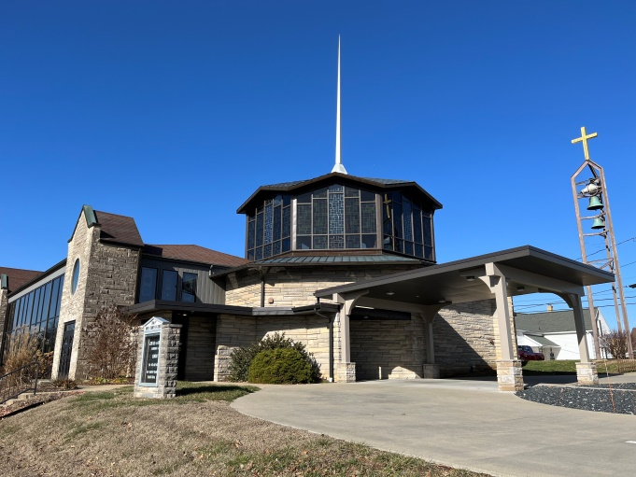

Are you interested in taking photos during Worship?

Trinity is looking for someone who would be willing to take pictures either before, during and after Worship on Sunday mornings at both the 8AM and 10:15AM Worship services for our Facebook page.

If you would be willing to help take pictures before, during or after Worship, please call the church office at (812) 482-4090 with your name, phone number and which service works best for you. Thank you!

Mommy and Me Playgroup
A “Mommy and Me Playgroup” will start meeting in our Tree House Preschool rooms. This group organized by a mom of one of our former Tree House students is excited to be using our space. The group is open to moms and their child/children ages five and under. Starting on March 3rd, 2023, they will meet the 1st and 3rd Fridays from 10:15 to 11:45 a.m. This will give Moms in the area a chance to meet while spending quality time with their children. The playgroup will have fun and active group games, simple crafts, and open play time in the Parish Hall.

If you have any questions or to sign up, contact Elizabeth Dellinger at elizabethanndellinger@gmail.com

Jasper Christian Academy – Thank you Card!

Dear Trinity,

We would like to express our heartfelt gratitude for the gift of $1,250.00. This will help us bless the children that God has sent our way.

As thankful as we are, we want to also say that we are sorry for the closing of your center. We have heard so many good comments about the work and love you have given to children throughout the years. We pray that we have such kind words said about us!

Again, thank you very much for thinking of us and blessing us with part of your grant money from DCCF.
Sincerely, Tina Eason
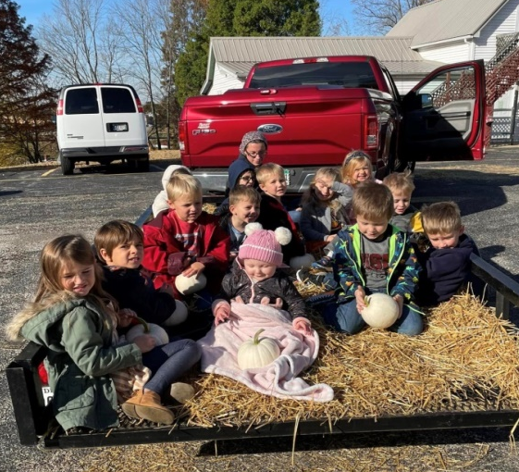
Administrator and Teacher
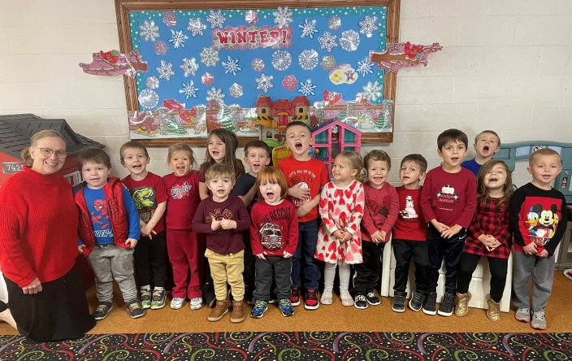

Little Spruce Nature School – Thank You Card!

Trinity Tree House,

Thank you for the generous donation to Little Spruce Nature School! We are humbled that you chose us. The donation will be used to further the education of our little people and hopefully purchase a permanent location for Little Spruce.

Thank you!
Little Spruce Nature School
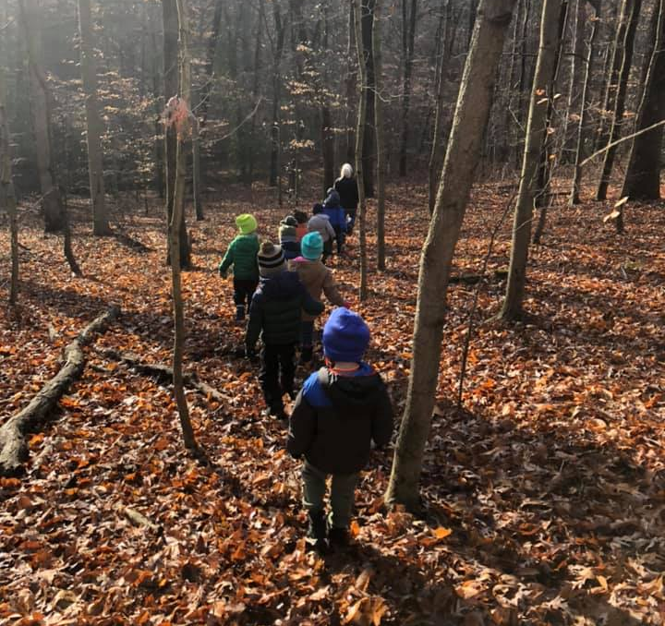

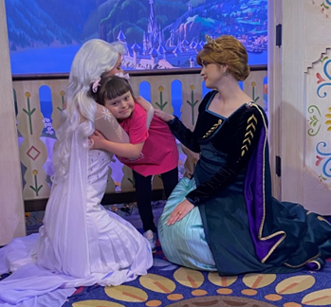

Taylor Popp, Trinity Church Secretary, is going
Over the Edge for Granted!

Taylor will be rappelling down CenterPoint Energy's 9-story building in downtown Evansville, IN on Saturday, April 29th to raise money for Granted. Granted is a nonprofit organization that funds wishes for our local children with terminal and life-threatening illnesses … including children right here in Dubois County and surrounding areas.

All of the money raised will go towards making magical Wishes come true and helping Granted ensure NO CHILD ever sits on a waiting list.

There are a few ways you can donate to this beautiful organization:

- Place money in the silver locked box outside the church office & be sure to label it “Granted”. Please make checks out to Taylor Popp & she will upload them to her personal Granted website

- Visit the website, www.ote4granted.com & be sure to select her name,
(Taylor Popp) when selecting a participant to support

Any amount is greatly appreciated! THANK YOU!
March 2023 - Worship Participants

March 5th – Second Sunday of Lent
Bible Readers: Bill Small, John Schnarr
Organist: Mary Ann Weisheit, Sarah Sergesketter Special Music: Gather & Sing Choir
Time with Young Disciples: Audra Jahn
Media Producer: Kurt Vonderheide Media: Adam Roth, Mark Blackgrave
Usher: Bill Small Usher & Lock-up: John & Janis Schnarr
Communion Prep: The Roth Family

March 12th – Third Sunday of Lent
Bible Readers: Selena Vonderheide, Doreen Lechner
Organist: Mary Ann Weisheit, Sarah Sergesketter
Time with Young Disciples: Pastor Karen
Media Producer: Nichole Lechner Media: Kurt Vonderheide, Kurt Heise
Usher: Selena Vonderheide Ushers & Lock-up: Alexander Thomas

March 19th – Fourth Sunday of Lent
Bible Readers: Mary Ann Weisheit, Lisa Schmidt
Organist: Mary Ann Weisheit, Sarah Sergesketter Special Music: Gather & Sing Choir
Time with Young Disciples: Casey Uebelhor
Media Producer: Mark Blackgrave Media: Kurt Vonderheide, Nichole Lechner
Usher: Mary Ann Weisheit Ushers & Lock-up: Phil & Lisa Schmidt

March 26th – Fifth Sunday of Lent
Bible Readers: Connie Schmitt, Melissa Blackgrave
Organist: Mary Ann Weisheit, Sarah Sergesketter
Time with Young Disciples: Heather Goodhue
Media Producer: Doreen Lechner Media: Mark Blackgrave, John Kahle
Usher: Connie Schmitt Ushers & Lock-up: Melissa Blackgrave

Thank you for being a participant and making Sunday Worship run smoothly!

March Birthdays

Name Date

Daniel | Kahle | 1
Rick | Hobson | 7
Sarah | Hopf | 9
Mike | Berger | 11
Neil | Astrike | 10
Shirlene | Dreher | 10
David | Scherer | 10
Phil | Schmidt | 13
Greg | Braun | 12
Lisa | Kincer | 14
Stacy | Hubster | 15
Terry | Kapp | 15
Jace | Goodhue | 15
William | Cole | 16
Jera | Hafele | 17
Maggie | Hubster | 19
Ty | Stockburger | 22
Melissa | Blackgrave | 22
Linda | Mehling | 24
Jared | Coller | 25
Treva | Heise | 25
Remi | Adams | 26
Sylvia | Adams | 29
Jerry | Brewer | 30
Kimberly | Aull | 31

March Anniversaries
Name Date Years
Philip & Melissa Hafele 3/17/2006 17

