Trinity United Church of Christ
April 2023

Worship: 8am & 10:15am

------------------------------------------------------------------------------------------------------------------

APRIL 2 – Matthew 21:1-11
“The Lord Needs Them!”

APRIL 6 – John 13:1-17, 31b-35
“In the Upper Room”

APRIL 9 – John 20:1-18
“I Have Seen the Lord!”

APRIL 16 – John 20:19-31
“What Thomas Missed”

APRIL 23 – Luke 24:13-35
“Being Made Known”

APRIL 30 – John 10:1-10
“The Good Shepherd”

Communion: Please pick up your communion wafer & cup as you enter the sanctuary.

Offering: Please place your gifts in the offering box as you enter or leave worship.

Contact Information
Pastor: Rev. Karen Fraser Moore
welwoman@hotmail.com, 618.920.3592

321 W. 8th Street … Jasper, Indiana 47546
(Corner of Clay & 8th Street)
Mailing Address: PO Box 386
Jasper, Indiana 47547-0386

Office Administrator: Taylor Popp
Office Phone: 812-482-4090
Office Hours: Monday – Thursday
9am – 1pm & 2pm - 3pm

Website: htps://www.trinityjasperucc.org
April Monthly Calendar

SU 2 8:00 & 10:15 am Worship
9:45 am Gather & Sing Choir
6:30 pm Austin Glover Concert

M 3 2:30 pm Prayer in the Sanctuary

TH 6 Maundy Thursday ~ Communion
7:00 pm Worship

F 7 Good Friday

SU 9 Easter ~ Communion
8:00 & 10:15 am Worship
9:45 am Gather & Sing Choir

M 10 2:30 pm Prayer in the sanctuary
7:00 pm Council Meeting

SU 16 8:00 & 10:15 am Worship
9:00 am Women’s Guild

M 17 Newsletter Articles Due
2:30 pm Prayer in the Sanctuary

T 18 4:00 pm Sunset Extension

SU 23 8:00 & 10:15 am Worship
9:00 am Men’s Fellowship

M 24 2:30 pm Prayer in the Sanctuary

T 25 Newsletter Sent

W 26 Church Office Closed

SU 30 8:00 & 10:15 am Worship

The church office is closed every Friday!

April Weekly Calendar

AA – Wednesdays & Fridays @ 7:00 pm
Sunday School – Sundays @ 9:00 am
Confirmation – Wednesdays @ 4:30 pm
Karen’s Kares
By the time this newsletter reaches many of you, we will be almost ready to begin our Holy Week experiences together. I want to emphasize the word together. As we move through this time of transition, I pray we can discover more opportunities to be together and work together as members of a Community of Faith. Our first opportunity to do so will be on Palm Sunday. Together, we are all invited to wave palms and parade around the sanctuary to shouts of “Hosanna! Blessed is the One who comes in the Name of the Lord! followed by preparing for the Austin Glover Concert and then decorating the Sanctuary with Easter Flowers. Please join us as we experiment with including as many folks as possible to work together to accomplish tasks we can then celebrate as a congregation.
In many congregations I have served over the past 40 years, there has often been a tendency for one or two people to simply volunteer to “get a needed project done in the simplest most timely way possible.” Given all of our busy lives which pull us in many directions each week, which is understandable. However, it seems to me, we may have lost our understanding of the value of doing things together and working together as a Community of Faith. When only one or two people cover a needed task, others may be left out or ignored, even those who could be highly gifted in the area related to the project.
In an order to begin to appreciate and add value to everyone involved, as well as others who are not yet involved, and to provide more opportunities for all members of our congregation to share their spiritual gifts, heart passions, abilities, personality types and life experiences, we will be experimenting with reorganizing the work of our Council Teams (Christian Education, Worship, Outreach, Parish Life and Property). A newly formed “Pastoral Support Team” is in the process of making contacts with some persons who may be interested stepping into those new co leadership positions.
On Monday, April 10th all members of all teams are invited to a meeting at 6:00 pm in the Sanctuary about how we are hoping to re-organize the Council Teams to move toward involving more people in the planning and carrying out of ideas and tending to tasks, while also adding some fresh new ideas to the mix. This meeting will provide everyone with an opportunity to share needs and concerns with the Council and consider new ideas as we move into a more inclusive future. Please come, even if you are not currently involved in a Team. We need your input to create more possibilities within our congregation for everyone’s spiritual development.
The more we can learn to function together as a Community of Faith, the more attractive the congregation can be to catch the interest of quality pastoral candidates. When we can learn to function in more healthy ways and include everyone, the more fun and excitement we can share.
It may be that by incorporating a new approach to our team leadership, we may need to develop ways to listen more carefully to one another and consider what is best for the entire team and or congregation, rather than only concentrate on how things have been done in the past. Listening to one another requires patience and also considering how our decisions will impact others. What messages are we sending to the Community of Jasper by the decisions we make? What messages of inclusion do we want to send to open the doors of possibility for others?

In Christ’s Love and Kare, Pastor KarenMerom, IN 478611m.org

Jack Astrike 4213 Baden Strasse, (812-634-7920)
Jasper, IN 47546

Corrine Clark Legacy Living, 1850 IN-56, Rm. # 202 (812-482-3482)
Jasper, IN 47546

Mariemma Huebner Northwood Retirement Community, Assisted Living (812-634-7945)
400 Pleasant View, Apt. # 23
Jasper, IN 47546

Sherry Malone 660 Rumbach Ave. Apt. #322 (812-582-2721)
Jasper, IN 47546

Claire Rohleder Legacy Living, 1850 IN-56, Rm. # 220 (812-482-3185)
Jasper, IN 47546

Violet Ruckriegel Scenic Hills, 710 E Sunrise Dr. Rm. # 503 (812-504-2578)
Ferdinand, IN 47532

Janice Sunderman Legacy Living, 1850 IN-56, Rm. # 134 (812-556-3196)
Jasper, IN 47546

Alene Frank Good Samaritan Society (Garden Ridge) (812-482-1722)
2515 Newton Street
Jasper, IN 47546

Others to keep in thought and prayer…

- Shirlene Dreher, David Fischer and Brian & Sandy Ferrell

Pray without ceasing…

- Pray for the people of Ukraine and give thanks for all who are welcoming refugees.

- Pray for ALL in need of healing; may God grant them strength and patience.

- Pray giving thanks that the Covid-19 numbers continue to fall, remembering that there are still those who are losing their lives. We give thanks for our health care workers!

- Pray for those impacted by the devastations from wind, fire & water.

- Pray for those families and communities where the young and elderly have been killed by senseless violence in various places in our country, including children in schools, those getting groceries, and those attending worship.

- Pray for our military, first responders and those in law enforcement.
Mission Alive at Trinity

Adopt a Family: Year-to-date we have collected $230.55

This year’s family is a single dad and his middle school son. They have given their permission for us to share a bit of their history with you. Both parents were together when the boy was young, but Mom eventually moved to Texas with him because Dad was struggling with drugs and had spent some time incarcerated. Dad has overcome his past issues and has been able to stay away from drugs for 5 years now!!! A job brought him to the southern Indiana area and he settled in Jasper. Recently, Mom notified him and indicated she did not feel capable of raising their adolescent son. The child also has been diagnosed with autism, so there are challenges besides the “usual” pre-teen issues. She wanted to send him to Jasper to live with Dad, who was eager for the chance to be with his son full-time. He is a great kid who enjoys school, Legos and drawing. They have enjoyed their time together, and Dad is determined to provide a safe, comfortable and loving home for them both.

When contacted about becoming our new Adopt-A-Family, he was overwhelmed. It will help him to continue “to climb his way out of the hole” (his words) he created for himself. He has much gratitude for our kindness. Already, we have provided Christmas gifts for both Dad and son (they say THANKS!!) plus the January change jar gift, a $150 gift card to IGA to be used for groceries and/or gas.
We appreciate your continued change jar support of our new family. Please remember them in your prayers, as well. We feel confident Trinity’s generosity will make 2023 a wonderful year for them!
With gratitude, The Outreach Team

Food Bank!
First, I wanted to say I took a nice amount of donations from Trinity to the Community Food Bank on Monday, March 20th. The fellow in charge of the volunteers who unload and stock the items said to tell our church, "Thank you, it is appreciated!"
If you heard my request on Sunday, March 19th from the Food Bank, or read the message they sent about empty shelves, and you responded, thank you. These are very unsettling times. We have to trust in God to provide for us, and we have to continue to help others, if possible.

All of us are struggling with paying more for groceries these days. Thank you for these donations.
The need in our community is greater than ever!

April item: Canned Vegetables
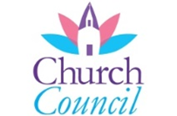
April Council Highlights

March Council Decisions:
- Approval was given for:
- Allocating $100 from Outreach to sponsor Mackenzie Blackman’s softball team

The next Council Meeting will be held on April 17th at 7:00pm.

Worship Team Request

A new addition to our services is the availability of a microphone when Worship participants share announcements, joys and concerns. The mic not only allows Pastor Karen to hear but also the others in the congregation.

It is the hope of both the Worship Team and the Church Council that we will be able to begin streaming our worship services at some point so that those unable to attend in person can continue to worship with us. It will, therefore, be important that all voices be heard during the service. We therefore request that when speaking during a service that the mic be used. Our ushers have been asked to bring the mic to you. We greatly appreciate your help and cooperation.

Trinity United Church of Christ Lenten Mission 2023

Many of you may see me as the lady at church who asks for money. I'm responsible for the Community Food Bank donations which we give all year long. Also, I'm the person who introduces the concept, or introduces the speaker, for the Lenten Mission. Our Lenten Mission lasts the 40 days of Lent AND the 6 Sundays, or 46 days.

As you are reading this, we are almost finished with Lent. Our goal, as you probably know is $5,000. In recent years we have collected over $6,000 for the mission. Our last amount printed in the Sunday bulletin was $2,025-- a long way from our goal.

If you are like me, you noticed some of our local non-profits made the news recently, as leadership stole money from the organization for which they worked. This was shocking to me and shook my faith in donating in general.

Yet, I'm convinced God sent Jesus as an example for us. We are to be loving people who help others. Please help Trinity meet and exceed this year's goal of $5,000 for Dove House in Jasper. Help women living there regain the kind of lives they were created to live.
Thank you, Jenny LaGrange

March Worship Attendance

Date Worship Attendance

March 5 8:00am 12 10:15am 48 Total 60
March 12 8:00am 12 10:15am 43 Total 55
March 19 8:00am 8 10:15am 35 Total 43
March 26 8:00am 11 10:15am 50 Total 61

Women’s Guild

In March, 37 hygene kits were assembled for Church World Service. The extra items that were left were taken to Dove House. Thanks to all that brought items for the kits.

The Guild and Men’s Fellowship will be hosting breakfast between services on Easter Sunday. There is a sign up sheet in the foyer for goodies for this meal.

Guild will meet on April 16th due to Easter the week before. Final plans will be made for our Spring Celebration with Augustana and St. Paul. This will be held May 3rd at 6:30pm.

It’s not too late to crochet, knit, etc. a prayer shawl for General Synod in June. Shawls may be brought to the Church office labeled for General Synod. Thank you!

Wednesday, May 3rd at 6:30pm – We will be hosting a Spring Celebration with the women of St. Paul and Augustana UCC in Holland.

Tuesday, May 9th at 12:00pm – Any interested Women of Lincolnland will meet again for lunch at 12pm. Restaurant location to be determined.

Easter Flower Garden
April 9, 2023

Celebration of:
Lisa and Phil Schmidt – in celebration of our family and Trinity UCC

John & Janis Schnarr – in celebration of family and friends

Mary Ann Weisheit – in celebration of my family

Dan & Sarah Sergesketter – in celebration of our families

John & Susan McGovren – in celebration of Reagan, Nora, and Ruby

Memory of:
The Goodhue Family – in memory of Dave Hubster, Ilene & Johnny Goodhue

Pamela Catt – in memory of Randy Catt

John & Susan McGovren – in memory of Joe and Roberta McGovren & Erwin and Martha Scott

Pastor Karen & Pastor Paul – in memory of Jennifer and our parents
Are you interested in taking photos during Worship?
Trinity is looking for someone who would be willing to take pictures either before, during or after Worship on Sunday mornings at both the 8AM and 10:15AM Worship services for our Facebook page.
If you would be willing to help take pictures before, during or after Worship, please call the church office at (812) 482-4090 with your name, phone number and which service works best for you. Thank you!
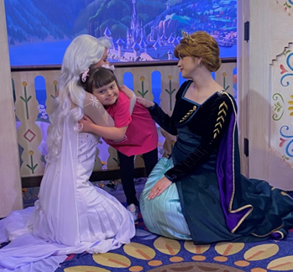

Taylor Popp, Trinity Church Secretary, is going
Over the Edge for Granted!

Taylor will be rappelling down CenterPoint Energy's 9-story building in downtown Evansville, IN on Saturday, April 29th to raise money for Granted. Granted is a nonprofit organization that funds wishes for our local children with terminal and life-threatening illnesses … including children right here in Dubois County and surrounding areas.

All of the money raised will go towards making magical Wishes come true and helping Granted ensure NO CHILD ever sits on a waiting list.

There are a few ways you can donate to this beautiful organization:

- Place money in the silver locked box outside the church office & be sure to label it “Granted”.

- Visit the website, www.ote4granted.com & be sure to select (Taylor Popp) when selecting a participant to support

Any amount is greatly appreciated! THANK YOU!
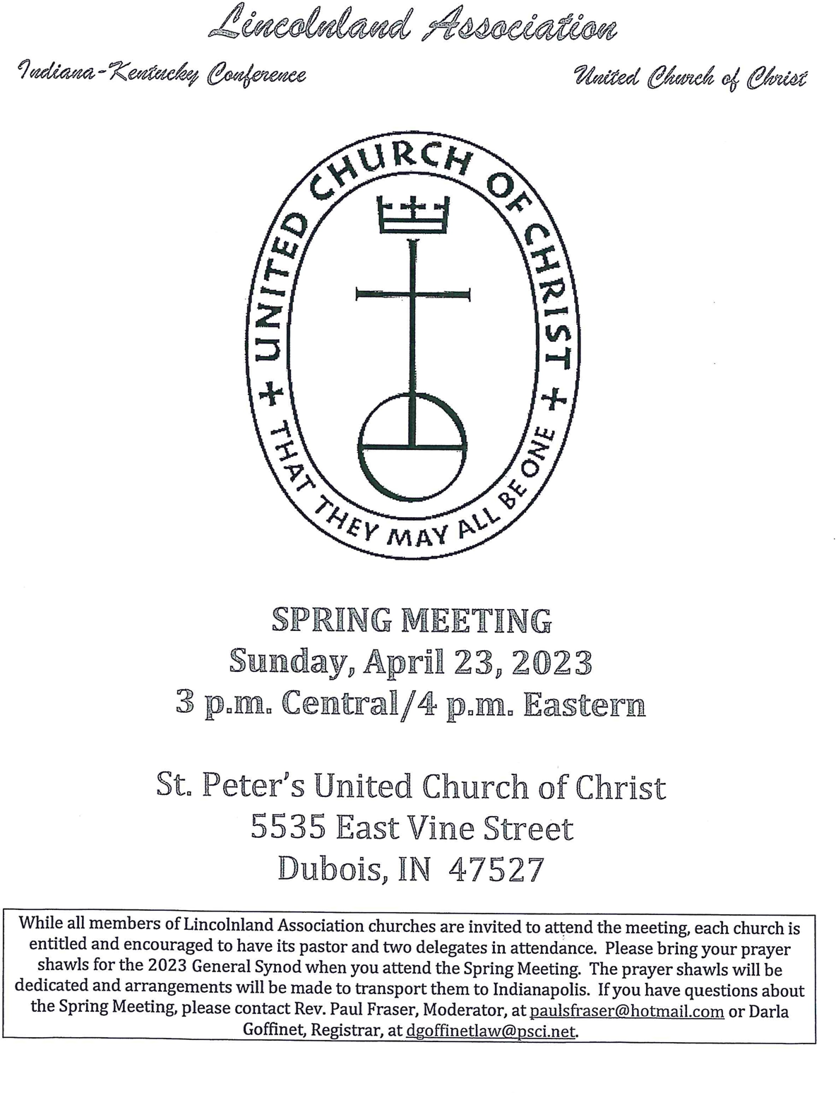

April 2023 - Worship Participants

April 2nd – Sixth Sunday in Lent
Bible Readers: Doug Bawel/Suellen Seng, Casey Uebelhor
Organist: Sarah Sergesketter Special Music: Gather & Sing Choir
Time with Young Disciples: Pastor Karen
Media Producer: Kurt Vonderheide Media: Kurt Vonderheide, Adam Roth
Usher: Doug Bawel/Suellen Seng
Usher & Lock-up: Larry LaGrange

April 6th – Maudy Thursday
Bible Readers: Confirmands Organist: Sarah Sergesketter
Media Producer: Nichole Lechner Media: Kurt Vonderheide
Usher & Lock-up: Bill Small
Communion: Susan McGovren

April 9th - Easter
Bible Readers: Selena Vonderheide, Susan McGovren Organist: Sarah Sergesketter
Time with Young Disciples: Audra Jahn
Media Producer: Mark Blackgrave Media: Kurt Vonderheide, Mark Blackgrave
Usher: Selena Vonderheide
Ushers & Lock-up: John & Susan McGovren
Communion Prep: Janis & John Schnarr

April 2023 - Worship Participants

April 16th – Second Sunday of Easter
Bible Readers: Mary Ann Weisheit, Karsen
Organist: Mary Ann Weisheit, Sarah Sergesketter Special Music: Gather & Sing Choir
Time with Young Disciples: Casey Uebelhor
Media Producer: Doreen Lechner Media: Kurt Heise, Nichole Lechner
Usher: Mary Ann Weisheit
Ushers & Lock-up: The Roth Family

April 23rd – Third Sunday of Easter
Bible Readers: Connie Schmitt, Pamela Catt
Organist: Mary Ann Weisheit, Sarah Sergesketter
Time with Young Disciples: Heather Goodhue
Media Producer: Kurt Vonderheide Media: Kurt Vonderheide, Adam Roth
Usher: Connie Schmitt
Ushers & Lock-up: Cindy Howard

April 30th – Fourth Sunday of Easter
Bible Readers: Doug Bawel/Suellen Seng, David Hubster
Organist: Mary Ann Weisheit, Sarah Sergesketter
Time with Young Disciples: Audra Jahn
Media Producer: Nichole Lechner Media: Kurt Vonderheide, John Kahle
Usher: Doug Bawel/Suellen Seng
Ushers & Lock-up: David Hubster

April Birthdays

Name Date

Lelani | Wittwer | 4 | 4
Hadley | Rumbach | 4 | 7
Kurt | Heise | 4 | 9
Sarah | Sergesketter | 4 | 11
Sabrina | Peters | 4 | 12
David | Peters | 4 | 14
Brett | Wright | 4 | 14
Brandi | Hellman | 4 | 16
Carol | Rasche | 4 | 18
Mitchell | Mauck | 4 | 19
Harrison | Hulsman | 4 | 22
Adrienne | Palmer | 4 | 24
Matt | May | 4 | 27

April Anniversaries
Name Date Years
Greg & Lisa Kincer 4/6/1985 37
Jeff & Ann Berg 4/15/1989 34
Kurt & Treva Heise 4/19/1986 37
Julie & Scott Beck 4/22/1978 45
Pat & Nick Seng 4/27/1974 49
David & Debie Stockburger 4/28/1973 50

Trinity Direct Debit Donations
The Church Council would like to know if there is sufficient interest in Trinity United Church of Christ to set up a program to allow Direct Debit Donations to Trinity UCC. The program would operate much the same way as programs offered by your utility company, your Prescription Drug programs, other Insurance Companies, or any business that you have agreed to make regular direct debits to. We are still doing some preliminary investigation work, but basically you would need to sign an Authorization Form that would provide Trinity with your authorization, some banking (financial institution) information, the amount you would like to donate on a regular basis and the interval of that donation, such as weekly or monthly. There should be no additional cost to you for doing this type of donation. Trinity would then on pre-established intervals, send a request to your bank directing funds to be taken from your predetermined account and send it to a predetermined Trinity UCC account. You of course would need to ensure that your account has sufficient funds to cover the amount of the donation. If at any time after your initial setup you wish to change the amount of your donation, the timing intervals, or any of the bank information provided, you would need to contact the Church Office.
Again, we are investigating the level of interest and would very much appreciate you returning this sheet with your preference indicated. We do not need any of your bank information or even your signature at this time, but would very much like to hear back from you by April 16, 2023. Please place a checkmark with your answer below and place this form in the offering box, drop it off at the Church Office or mail it to the Church Office. Thank you for your prompt attention and participation.

(Yes) I would be interested in participating in the Trinity UCC Direct Debit Donation program____________________

(No) I would not be interested in participating in the Trinity UCC Direct Debit Donation program_____________________

